LIST OF MEMBERS OF STATE HAJ COMMITTEE, UTTAR PRADESH

SR. NO. | PHOTO AND NAME OF MEMBER OF STATE HAJ COMMITTEE | ADDRESS | MOBILE NUMBER | GAZETTE NOTIFICATION NO. AND DATE
1 | 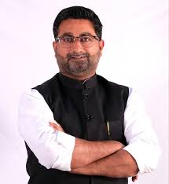  MR. DANISH AZAD ANSARI | Hon’ble Minister of Minority Welfare Department Muslim Waqf & Haj, Government of Uttar Pradesh. | 9454463500 | Minority Welfare Department Section-4 Gazette Notification No 154/FiftyTwo-4-2025-13(H)/2017 Lucknow. 14-05-2025
2 | 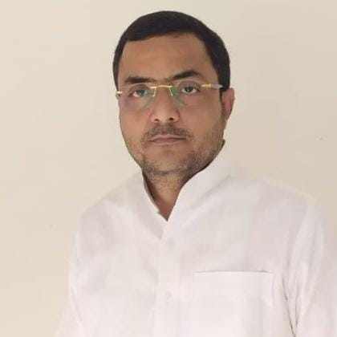  MR. MOHD IFTEKHAR HUSAIN | H. No 395, Garden House, Zahidabad, Gorakhnath, Gorakhpur-273015 | 9935850648  9415283416  7379114035 | Minority Welfare Department Section-4 Gazette Notification No 154/FiftyTwo-4-2025-13(H)/2017 Lucknow. 14-05-2025
3 | 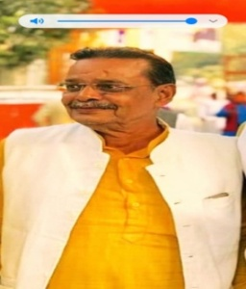  MR. SYED KALBE HUSAIN (KABBAN NAWAB) | H. No. 450/148/5kha, Muftiganj Kale Ki Gali, Thakurganj, Lucknow-226003 | 9935850646  9415519097  8318200080 | Minority Welfare Department Section-4 Gazette Notification No 154/FiftyTwo-4-2025-13(H)/2017 Lucknow. 14-05-2025
4 | 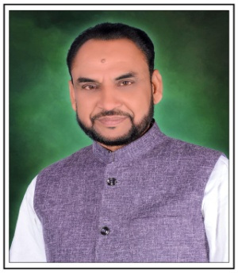  MR. WALI MOHAMMAD | 52-G AREA ACHARJAN NAGAR PANCHAYAT, GOPAMAU, HARDOI-241404 | 9935850641  9839974770 | Minority Welfare Department Section-4 Gazette Notification No 154/FiftyTwo-4-2025-13(H)/2017 Lucknow. 14-05-2025
5 | 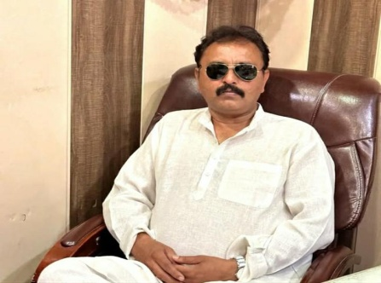  MR. NADEEMUL HASAN | 05 DHAURA TANDA, DHURA TANDA R BAREILLY-243202 | 9935850642  9758759960 | Minority Welfare Department Section-4 Gazette Notification No 154/FiftyTwo-4-2025-13(H)/2017 Lucknow. 14-05-2025

6 | 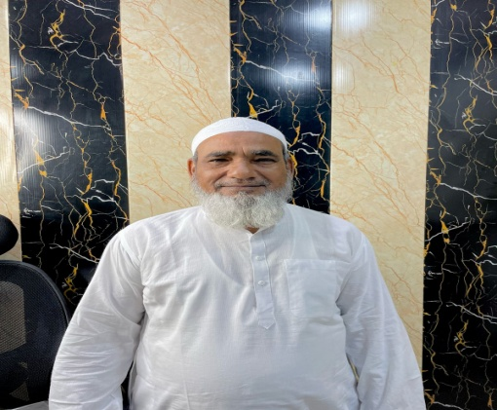  MR. JUNAID AHMAD ANSARI | 84-GORAKHNATH ROAD, NEAR MADARSA ZIAUL ULOOM, OLD GORAKHPUR, GORAKHNATH, GORAKHPUR-273015 | 9935850647  9580389101  7392887415 | Minority Welfare Department Section-4 Gazette Notification No 154/FiftyTwo-4-2025-13(H)/2017 Lucknow. 14-05-2025
7 | 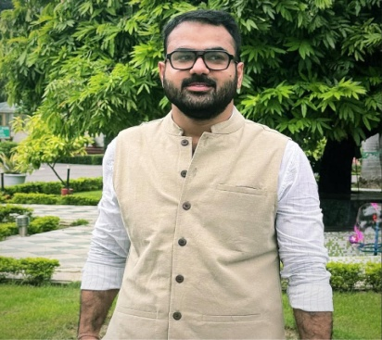  MR. SYED ALI WARSI | SHAH WARIS BHAWAN, MOHALLA HUJJAJI-1 TEHSIL NAWABGANJ, DEWA SHARIF, BARABANKI-225301 | 9935850643  9984244599  9125655000 | Minority Welfare Department Section-4 Gazette Notification No 154/FiftyTwo-4-2025-13(H)/2017 Lucknow. 14-05-2025
8 | 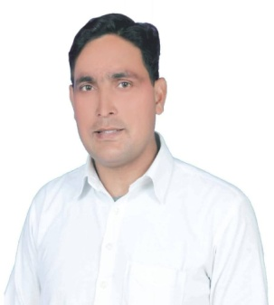  HAFIZ AIJAZ AHMAD (SHAHIN ANSARI) | GRAM GANGAPUR KADEEM, RAMPUR CITY, RAMPUR-244901 | 9935850644  9761457036  9412644285 | Minority Welfare Department Section-4 Gazette Notification No 154/FiftyTwo-4-2025-13(H)/2017 Lucknow. 14-05-2025
9 | 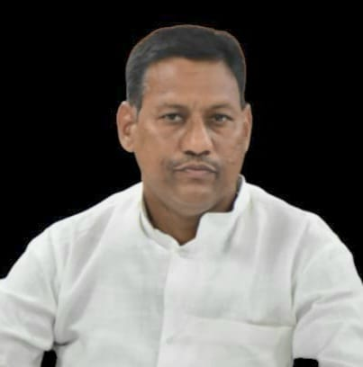  MR. JAVED KAMAR KHAN | GRAM SABHA BAHERI, POST BAHERI, THANA KOTWALI, BALIYA-277001 | 9935850649  7860654575  9415659915 | Minority Welfare Department Section-4 Gazette Notification No 154/FiftyTwo-4-2025-13(H)/2017 Lucknow. 14-05-2025
10 | 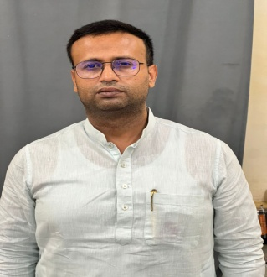  MR. KAMRAN KHAN | VILA-M-08, SHALIMAR GARDEN, I.I.M. ROAD, LUCKNOW-226020 | 9935850645  9415087301  8318266431 | Minority Welfare Department Section-4 Gazette Notification No 154/FiftyTwo-4-2025-13(H)/2017 Lucknow. 14-05-2025
11 | 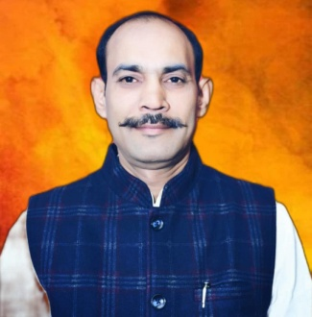  MR. QAMRUDDIN (JUGNU) | PLOT NO. 54, 55C J. V. GARDEN, PARA, LUCKNOW-226017 | 9935850650  9129216668 | Minority Welfare Department Section-4 Gazette Notification No 154/FiftyTwo-4-2025-13(H)/2017 Lucknow. 14-05-2025
12 | 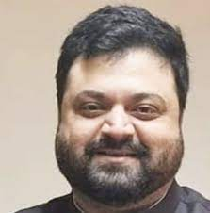  MR. ALI ZAIDI | Chairman,  Shia Waqf Board,  Indira Bhawan 8th Floor,  Ashok Marg, Lucknow-226001 | 9554444491 | Minority Welfare Department Section-4 Gazette Notification No M-52/52-4-2021-13(H)/2017 Lucknow. 24-12-2021
13 | 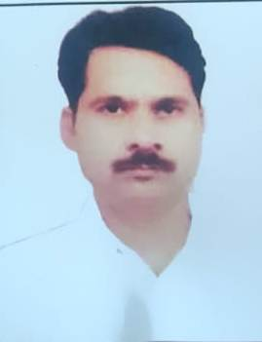  MR. S. P. TIWARI | Executive Officer,  State Haj Committee, U. P.  Maulana Ali Miyan Memorial Haj House, Sarojani Nagar, Kanpur Road, Lukcnow 226008 | 9415365117 | Minority Welfare Department Section-4 Gazette Notification No M-52/52-4-2021-13(H)/2017 Lucknow. 24-12-2021

